Web Server Deployment and HAProxy Configuration

- Install nginx and run nginx on port number 81.
To install Nginx and run it on port 81, you need to install the package, update its default server block configuration, and restart the service.
The guide below uses Ubuntu/Debian syntax, which is standard for most Linux environments.
Step 1: Install Nginx
Update your package list and install the NGINX Open Source package:
bash
sudo apt update
sudo apt install nginx -y
Use code with caution.
Step 2: Configure Nginx to Listen on Port 81
Open the default website configuration file using a text editor like nano:
bash
sudo nano /etc/nginx/sites-available/default
Use code with caution.
Find the lines that specify listen 80; and listen [::]:80;. Change them from 80 to 81:
nginx
server {
listen 81 default_server;
listen [::]:81 default_server;
...
}
Use code with caution.
Save and exit the file (Press Ctrl+O, Enter, then Ctrl+X).
Step 3: Test and Restart Nginx
- Verify the configuration syntax to catch any typos:
bash
sudo nginx -t
Use code with caution.
- Restart the Nginx service to apply your change:
bash
sudo systemctl restart nginx
Use code with caution.
Step 4: Verify the Port Update
Confirm that Nginx is running and listening on port 81 using the following command:
bash
sudo ss -tulpn | grep :81
Use code with caution.
You can also verify it directly by opening your browser and navigating to http://localhost:81 or running curl http://localhost:81 in your terminal.

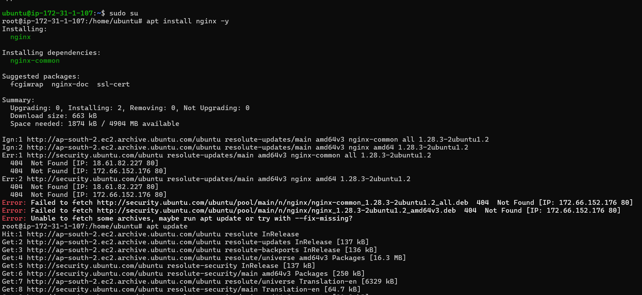

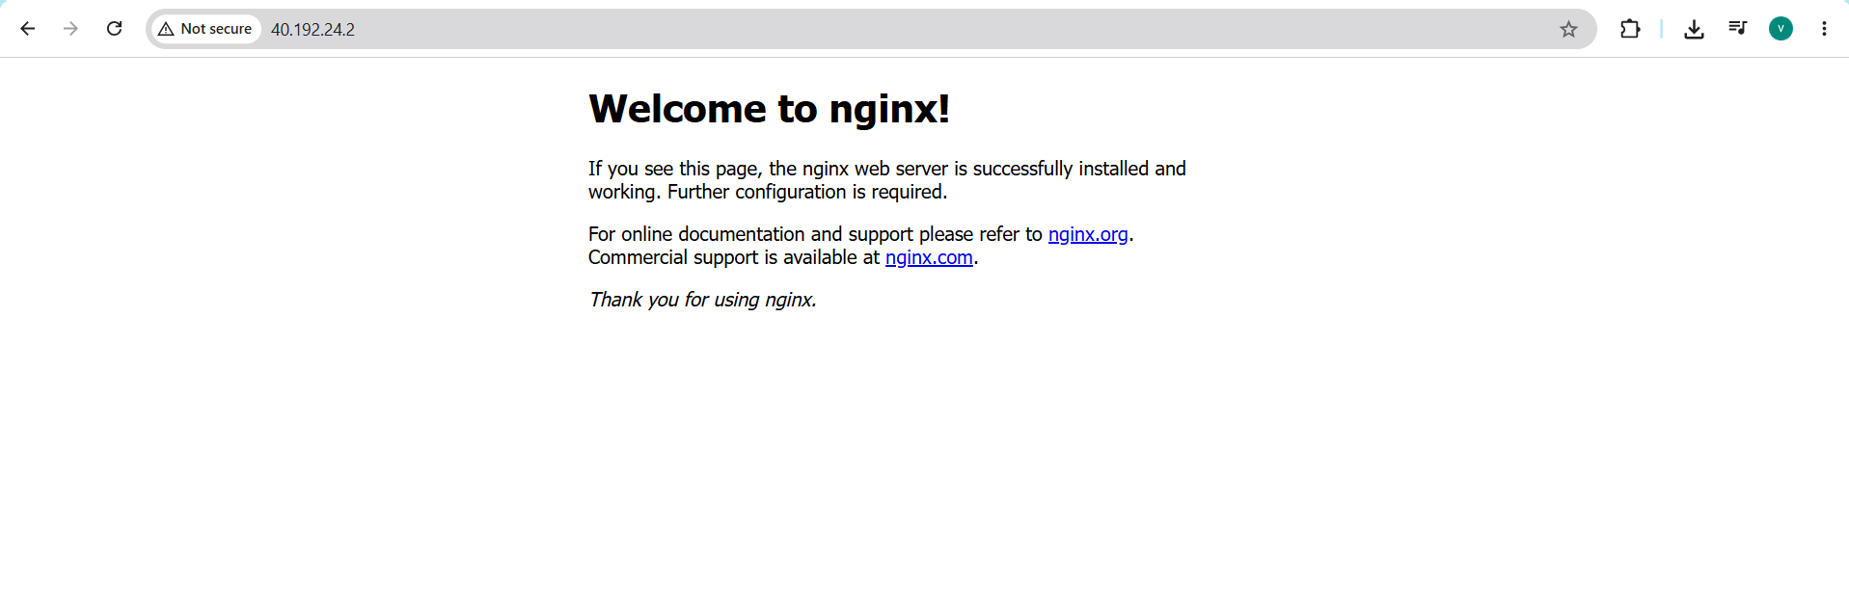

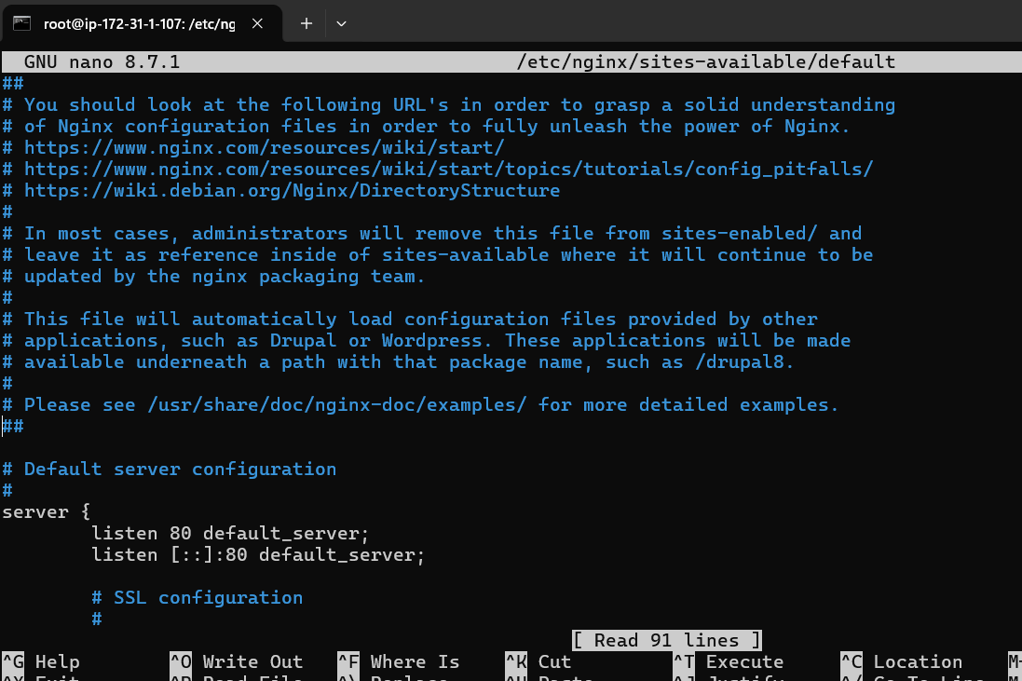

2.Deploy a sample index.html file on nginx.

To deploy a sample index.html file on an NGINX Open Source web server, you must place your HTML file in the NGINX document root and update its server configuration.
Here is the step-by-step process for Ubuntu/Debian systems.
1. Install NGINX
Update your package list and install the web server if you haven't already.
bash
sudo apt update
sudo apt install nginx -y
Use code with caution.
2. Create the Sample HTML File
Create a new directory for your website files and generate a standard sample index.html.
bash
sudo mkdir -p /var/www/mysite
Use code with caution.
Open a text editor to create the file:
bash
sudo nano /var/www/mysite/index.html
Use code with caution.
Paste this basic HTML template, then save and exit (Press Ctrl+O, Enter, then Ctrl+X):
html
<!DOCTYPE html>
<html lang="en">
<head>
<meta charset="UTF-8">
<meta name="viewport" content="width=device-width, initial-scale=1.0">
<title>Hello NGINX</title>
</head>
<body>
<h1>Success! Your sample index.html file is live on NGINX.</h1>
</body>
</html>
Use code with caution.
3. Configure the NGINX Server Block
Create a custom server block configuration file to instruct NGINX where to look for your content.
bash
sudo nano /etc/nginx/sites-available/mysite
Use code with caution.
Add the following configuration code:
nginx
server {
listen 80;
server_name localhost; # Replace with your domain name or public IP if applicable

root /var/www/mysite;
index index.html;

location / {
try_files $uri $uri/ =404;
}
}
Use code with caution.
4. Enable Configuration and Restart NGINX
Enable your new block by linking it to the sites-enabled directory, remove the default page to prevent conflicts, and reload the server.
bash
# Link the new site
sudo ln -s /etc/nginx/sites-available/mysite /etc/nginx/sites-enabled/

# Remove default site configuration
sudo rm /etc/nginx/sites-enabled/default

# Verify configuration syntax is correct
sudo nginx -t

# Restart NGINX to apply changes
sudo systemctl restart nginx
Use code with caution.
5. Verify the Deployment
Open your browser and navigate to http://localhost. If you are deploying on a remote cloud instance, use the server's public IP address instead. You will see your sample page live.
If you plan to scale this configuration later, you can look up specific syntax updates on the NGINX Admin Guide to set up caching or reverse proxies.


- Install Apache and run Apache on port number 82

To install Apache and run it on port 82 alongside Nginx, you must install the Apache package, update its core port configuration file, modify its default virtual host file, and restart the service.
Below is the step-by-step guide for Debian/Ubuntu-based systems.
1. Install Apache
First, update your package repository list and install Apache:
bash
sudo apt update
sudo apt install apache2 -y
Use code with caution.
2. Configure Apache Listening Port
By default, Apache listens on port 80, which conflicts with Nginx. Open the ports configuration file:
bash
sudo nano /etc/apache2/ports.conf
Use code with caution.
Find the line Listen 80 and change it to 82:
apache
Listen 82
Use code with caution.
Save and exit the file (Press Ctrl+O, Enter, then Ctrl+X).
3. Update the Apache Virtual Host
Next, modify the default site configuration so it matches the new port:
bash
sudo nano /etc/apache2/sites-available/000-default.conf
Use code with caution.
Change the opening VirtualHost tag from <VirtualHost *:80> to 82:
apache
<VirtualHost *:82>
Use code with caution.
Save and exit the file.
4. Restart Apache Service
Apply the changes by restarting Apache:
bash
sudo systemctl restart apache2
Use code with caution.
5. Verify the Port Change
Verify that Apache is successfully running on port 82 using the ss or netstat command:
bash
sudo ss -tlnp | grep 82
Use code with caution.
You should see apache2 listening on *:82.
Optional: Routing Nginx to Apache
If your goal is to have Nginx act as a reverse proxy that forwards traffic to Apache on port 82, add a proxy_pass directive inside your Nginx server block:
nginx
server {
listen 80;
server_name your_domain.com;

location / {
proxy_pass http://127.0.0.1:82;
proxy_set_header Host $host;
proxy_set_header X-Real-IP $remote_addr;
}
}

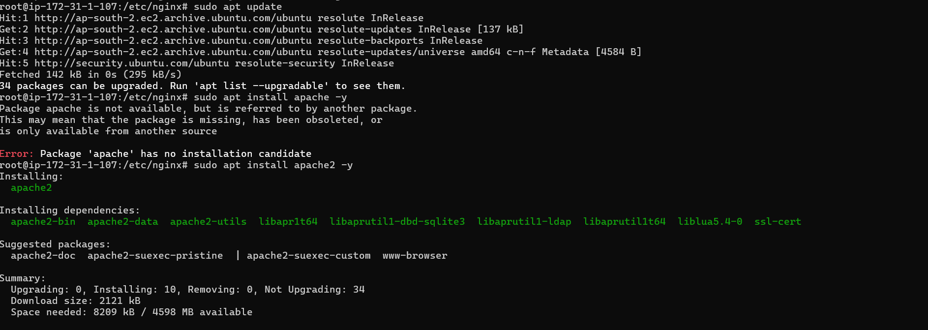

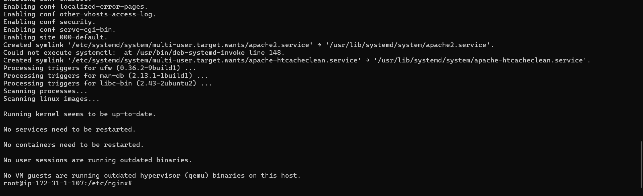
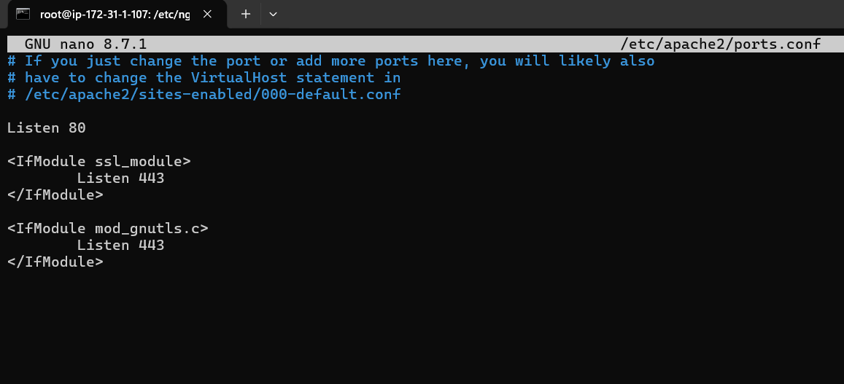
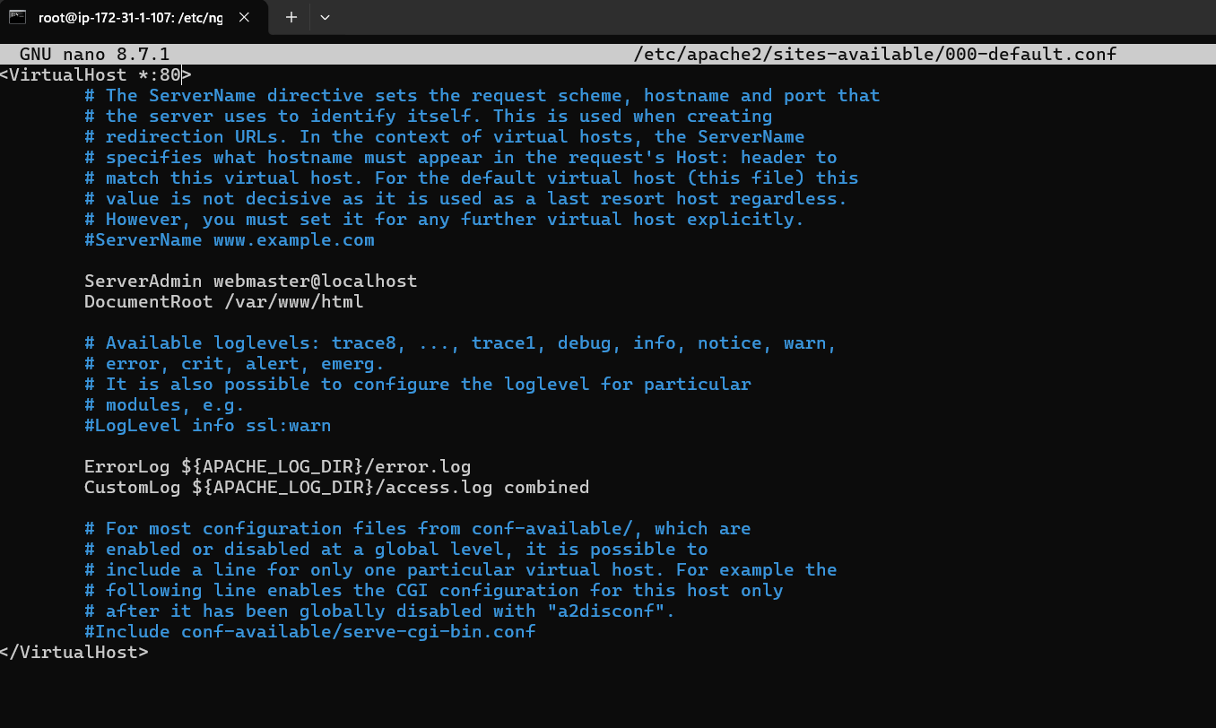
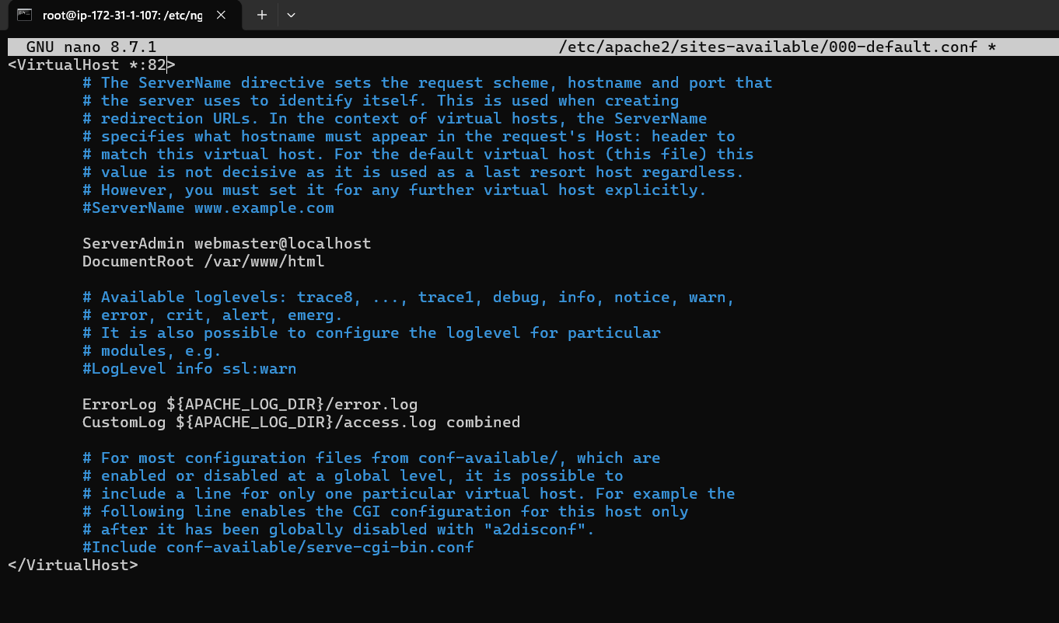

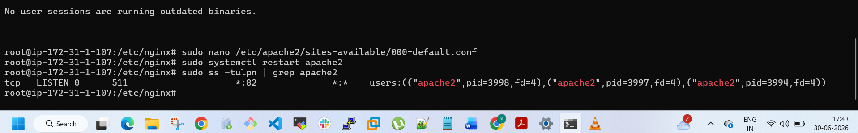

4. Deploy a sample index.html file on Apache.
To deploy a sample index.html file on Apache in Ubuntu, you must place your file inside the default web root directory located at /var/www/html/. Apache automatically serves any file named index.html found in this directory when a visitor accesses your server's IP address. [1, 2, 3]
Follow this quick guide to install Apache, create your custom sample webpage, and verify that it works properly.
1. Install Apache
Update your package index and install the Apache server by running these commands in your terminal:
bash
sudo apt update
sudo apt install apache2 -y
Use code with caution.
2. Verify Apache is Running
Ensure the service is active using the systemctl command:
bash
sudo systemctl status apache2
Use code with caution.
(You should see an active (running) status in the terminal output.)
3. Replace the Default File with a Sample HTML File
Apache creates a default landing page when installed. Move or remove it, then create your custom index.html:
bash
# Rename the existing default page as a backup
sudo mv /var/www/html/index.html /var/www/html/index.html.bak

# Create and open a new index.html file using the Nano text editor
sudo nano /var/www/html/index.html
Use code with caution.
Paste the following sample HTML code into the file editor:
html
<!DOCTYPE html>
<html lang="en">
<head>
<meta charset="UTF-8">
<title>Apache Ubuntu Deployment</title>
</head>
<body>
<h1>Success! Your custom page is online.</h1>
<p>This sample index.html file is running on an Apache web server on Ubuntu.</p>
</body>
</html>
Use code with caution.
- Press CTRL + O then Enter to save.
- Press CTRL + X to exit the editor.
4. Adjust Permissions
Make sure Apache has the correct permissions to read your file:
bash
sudo chown -R www-data:www-data /var/www/html/
sudo chmod 644 /var/www/html/index.html
Use code with caution.
5. Open the Webpage
Find your server's public or local IP address:
bash
hostname -I
Use code with caution.
Open a web browser on your computer and type your server's IP address into the address bar:
text
http://your_server_ip
Use code with caution.
You will immediately see your newly deployed custom sample page.
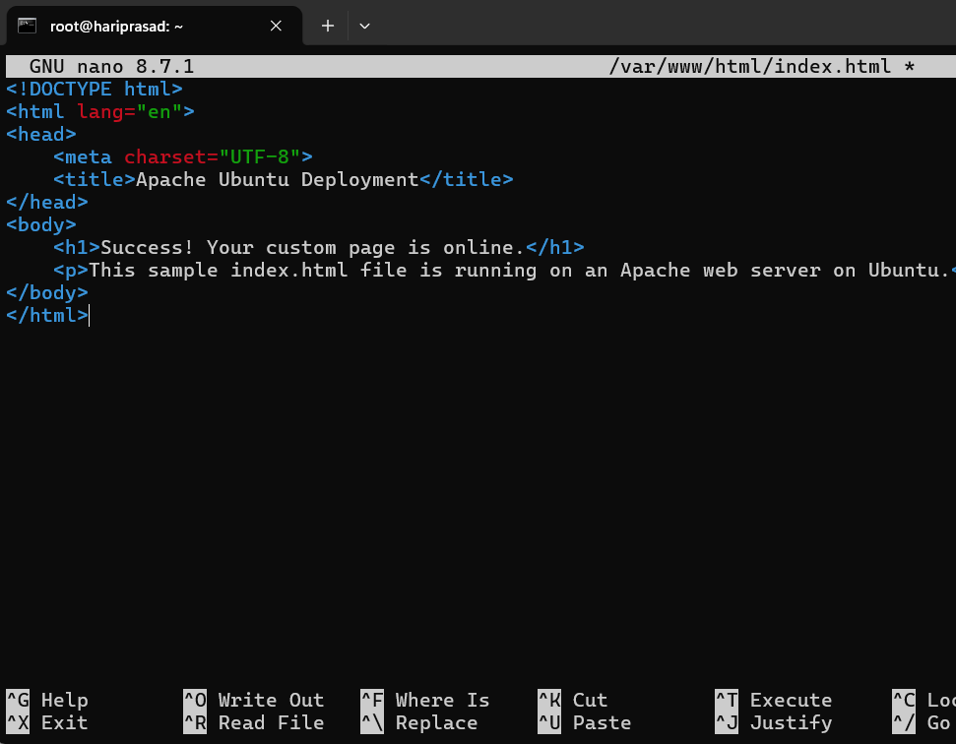

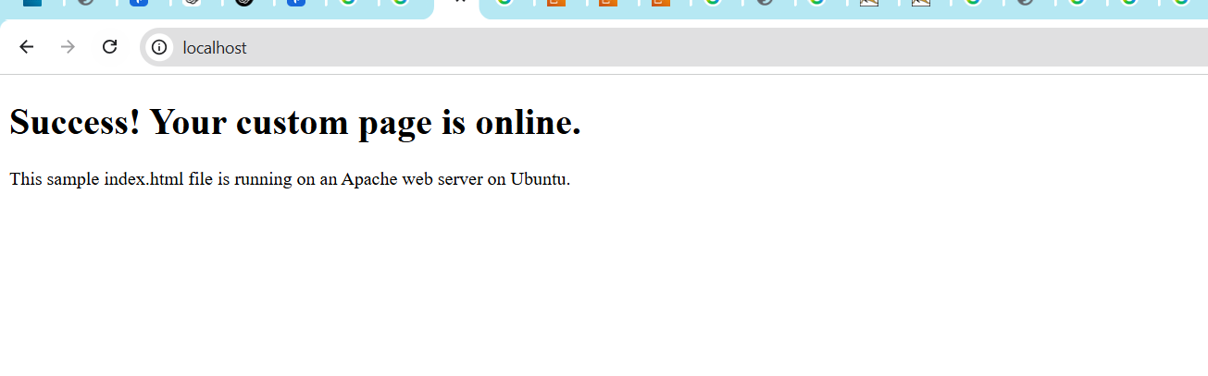

5.Install Apache tomcat on port number 8082
To install Apache Tomcat and configure it to run on port 8082, you need to install the server normally and modify its server.xml configuration file.
Here is how to set up Tomcat on port 8082 for both Windows and Linux environments.
🌐 Method 1: Windows (Using the Installer)
If you use the Windows Service Installer, you can define the port directly during the setup wizard.
- Download the Windows Service Installer executable from the Apache Tomcat Official Download Page.
- Run the installer and click Next until you reach the Configuration Options screen.
- Locate the HTTP/1.1 Connector Port field (which defaults to 8080).
- Change the value from 8080 to 8082.
- Complete the installation wizard. Tomcat will automatically run as a Windows service on your new port.

🐧 Method 2: Linux & Archive Installations (Manual Configuration)
If you installed Tomcat via a .tar.gz or .zip archive, you must update the core XML configuration file.
1. Locate the Configuration File
Open your terminal and find your Tomcat installation directory. Locate the server.xml file inside the conf folder. For instance:
- Archive installations: /opt/tomcat/conf/server.xml
- Ubuntu APT installations: /etc/tomcat9/server.xml or /var/lib/tomcat9/conf/server.xml
2. Edit the Connector Port
Open the file using a text editor like Nano or Vim:
bash
sudo nano /opt/tomcat/conf/server.xml
Use code with caution.
Scroll down or use Ctrl + W to find the default HTTP connector configuration. It looks like this:
xml
<Connector port="8080" protocol="HTTP/1.1"
connectionTimeout="20000"
redirectPort="8443" />
Use code with caution.
Modify the port value to 8082:
xml
<Connector port="8082" protocol="HTTP/1.1"
connectionTimeout="20000"
redirectPort="8443" />
Use code with caution.
Save and exit the text editor (In Nano, press Ctrl + O, Enter, then Ctrl + X).
3. Restart the Tomcat Service
Apply the new port assignment by restarting your Tomcat instance.
- For Archive installations:
bash
/opt/tomcat/bin/shutdown.sh
/opt/tomcat/bin/startup.sh
Use code with caution.
- For Systemd service installations:
bash
sudo systemctl restart tomcat
Use code with caution.

🧪 Verify the Installation
Open your preferred web browser and navigate to the local host address:
text
http://localhost:8082
Use code with caution.
If configured correctly, the classic Apache Tomcat status page will display on your screen

Note: unable to edit port no due to unregistered version.
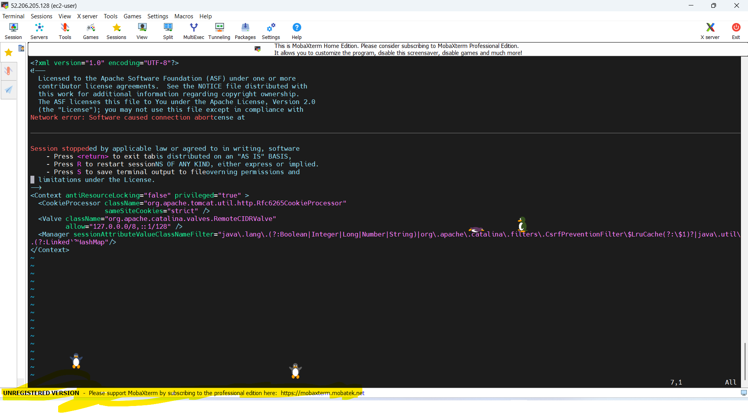
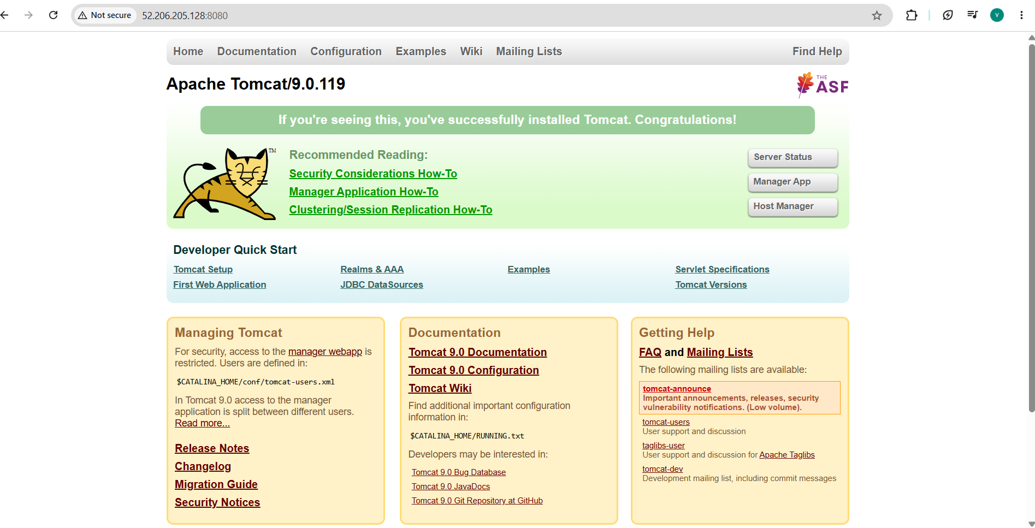

- Deploy a sample app on webapps:
To deploy a sample application, you must choose whether you are deploying locally to a Java web container like Apache Tomcat or deploying to a cloud platform like Azure App Service.
The quickest way to deploy a sample .war file to a local Tomcat webapps directory is to paste the file directly into your server's installation directory. The most efficient way to deploy a dynamic web app to Azure WebApps (App Service) is by using the Azure CLI az webapp up command.

Option 1: Local Deployment (Apache Tomcat webapps folder)
If your "webapps" refers to the local Tomcat server directory, use these steps:
- Download your app package: Obtain your application file, typically compiled as a .war file (e.g., sample.war).
- Locate the directory: Navigate to your Tomcat installation path, specifically the webapps folder (e.g., <TOMCAT_HOME>/webapps/).
- Deploy the file: Copy and paste your .war file directly into that folder.
- Start the server: Run ./startup.sh (Linux/Mac) or startup.bat (Windows) from the Tomcat bin directory. Tomcat will automatically extract and run your app.
- Access the application: Open your browser and go to http://localhost:8080/sample.

Option 2: Cloud Deployment (Azure WebApps)
If "webapps" refers to cloud hosting via Azure App Service, use the Azure CLI to spin up and launch your code instantly:
- Open your project: Launch your terminal and navigate to your sample application's root directory.
- Log in to Azure: Run the sign-in command to connect your terminal to your account:
bash
az login
Use code with caution.
- Deploy with one command: Execute the following command, replacing <your-unique-app-name> with a globally unique name:
bash
az webapp up --name <your-unique-app-name> --html
Use code with caution.
(Note: Change --html to --runtime "NODE:18-lts" or --runtime "PYTHON:3.10" depending on your code stack).
- Launch the live URL: The terminal will spit out a target web URL (e.g., https://<your-unique-app-name>.azurewebsites.net) once deployment completes.
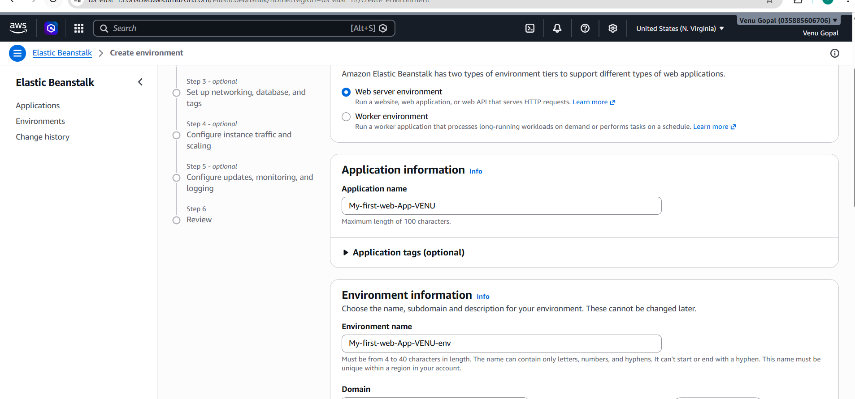
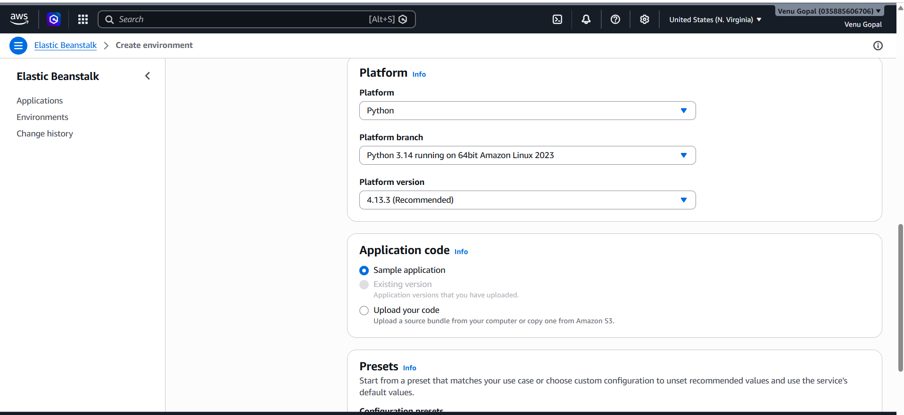
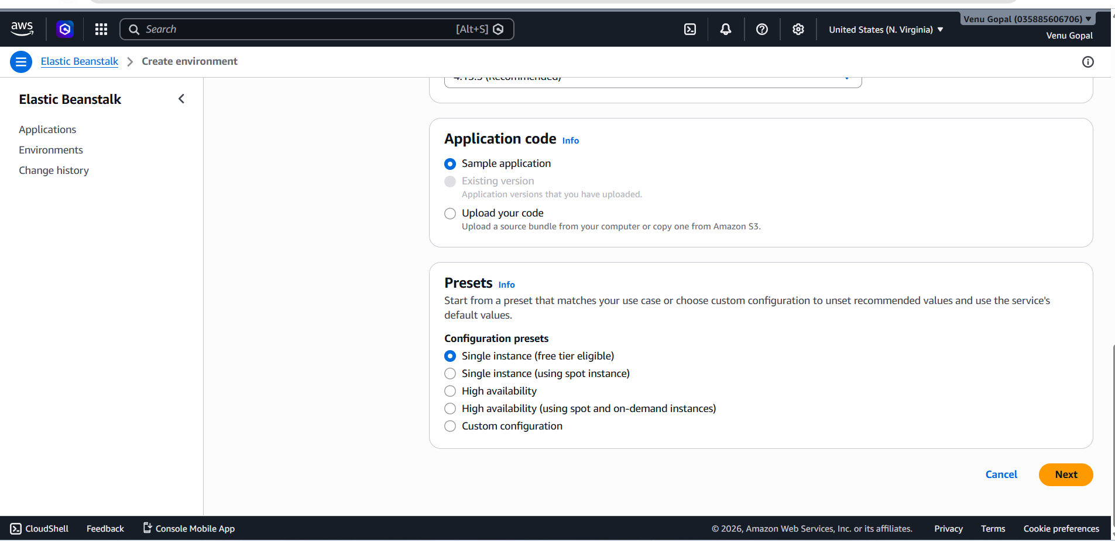
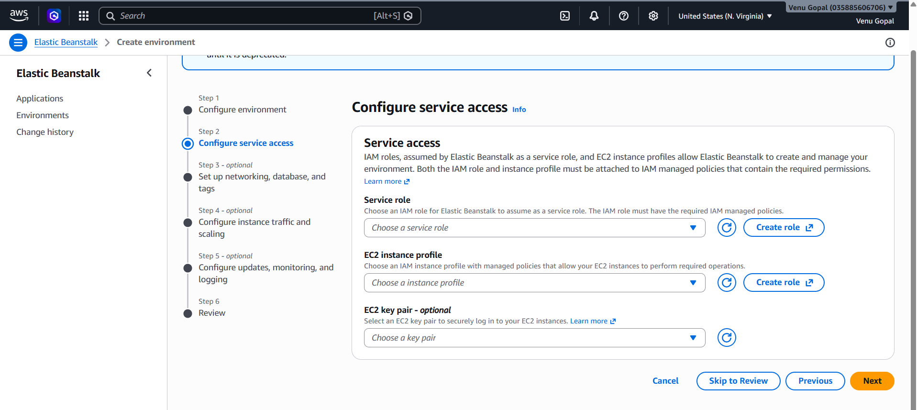
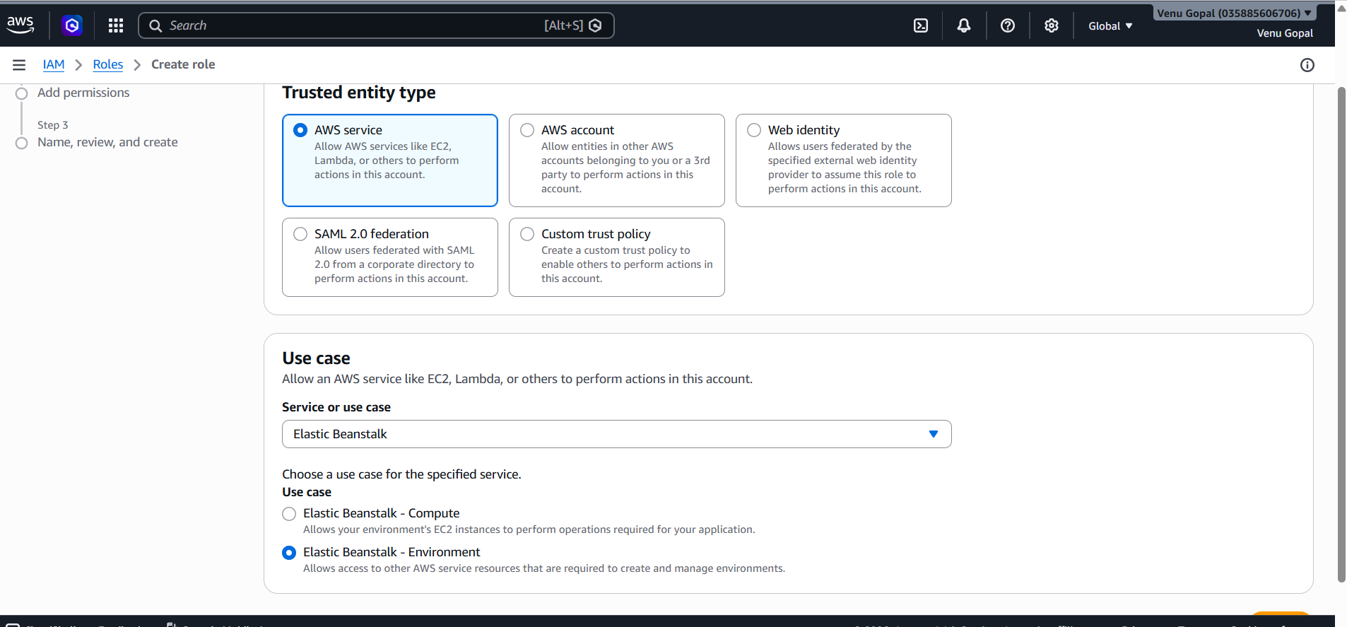
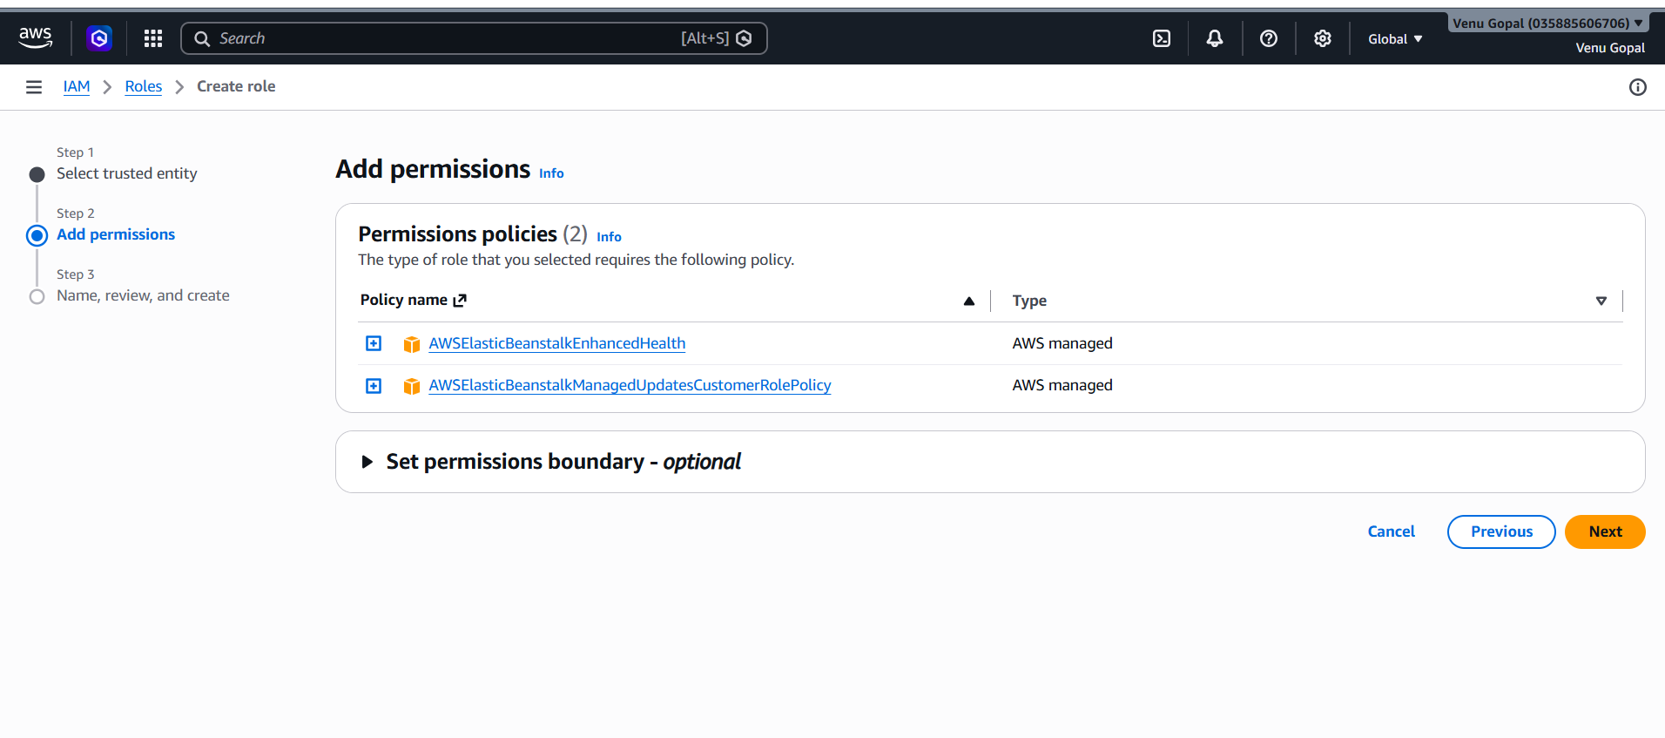
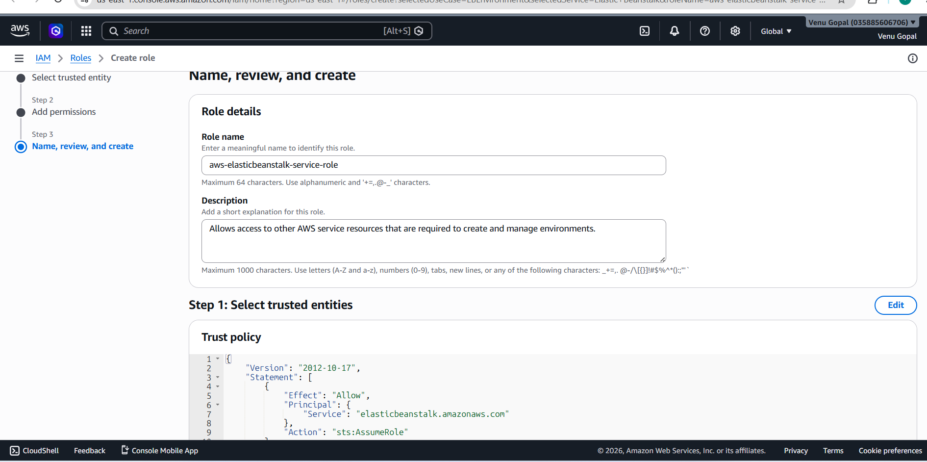
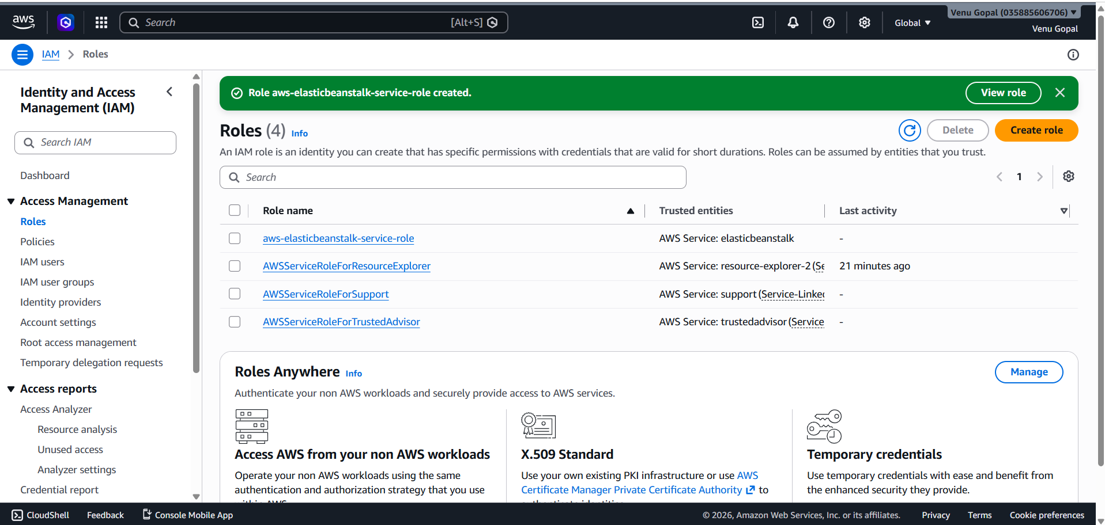

For EC2 instance profile creating role:
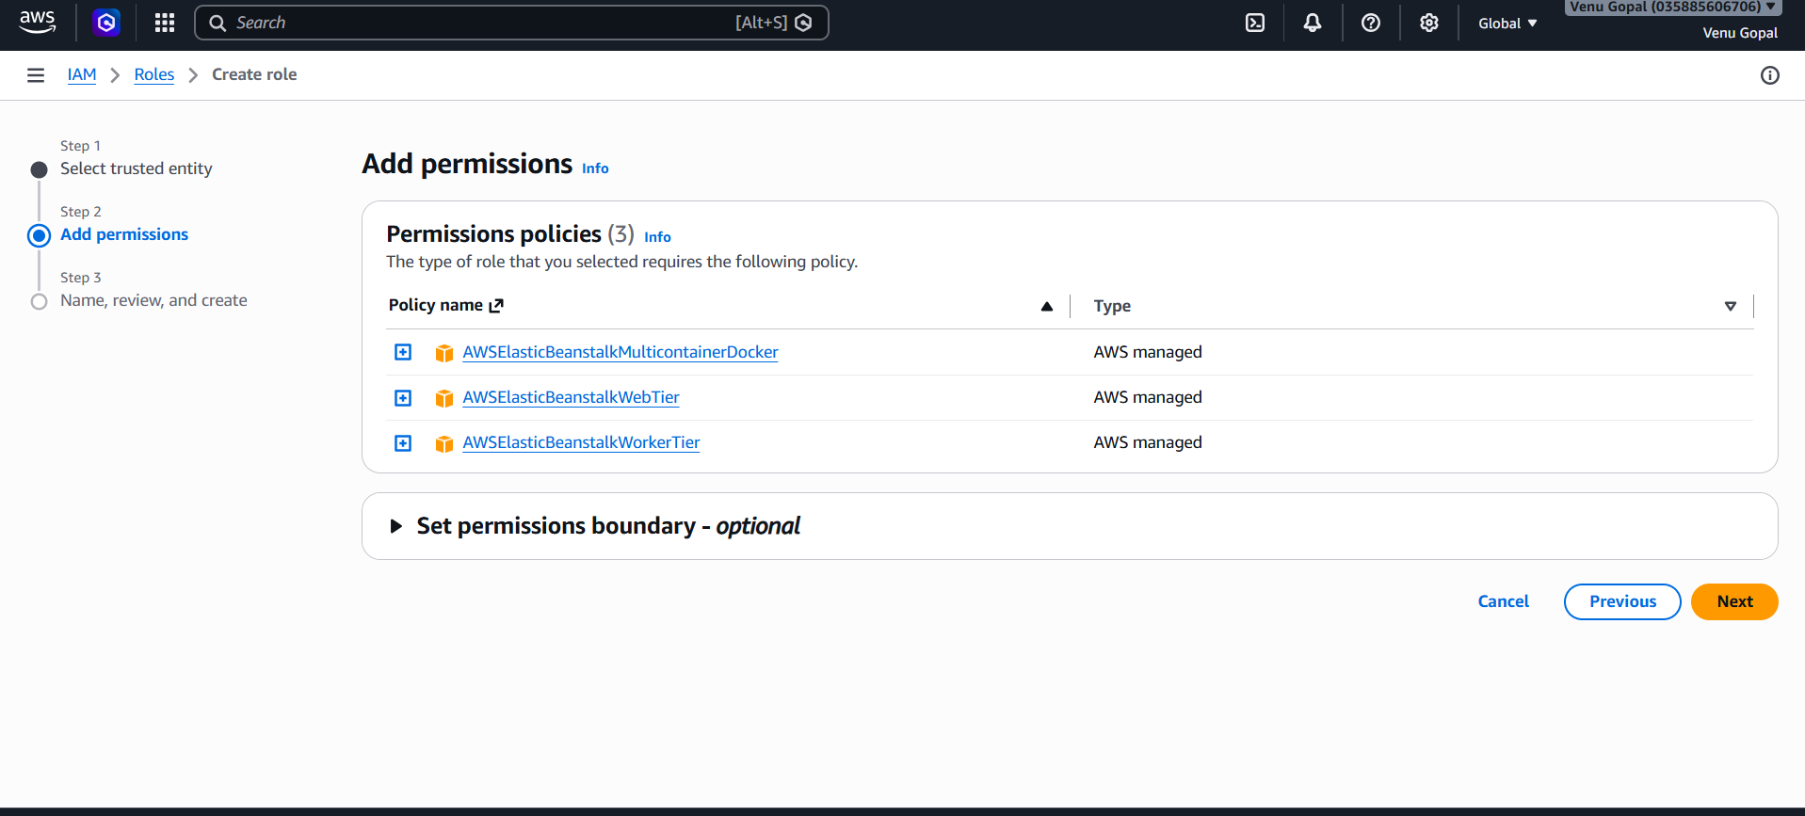
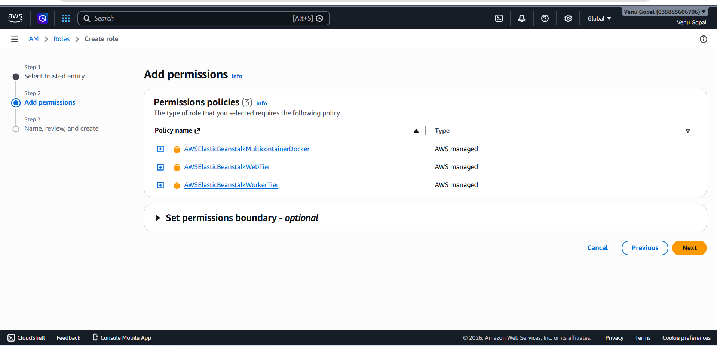
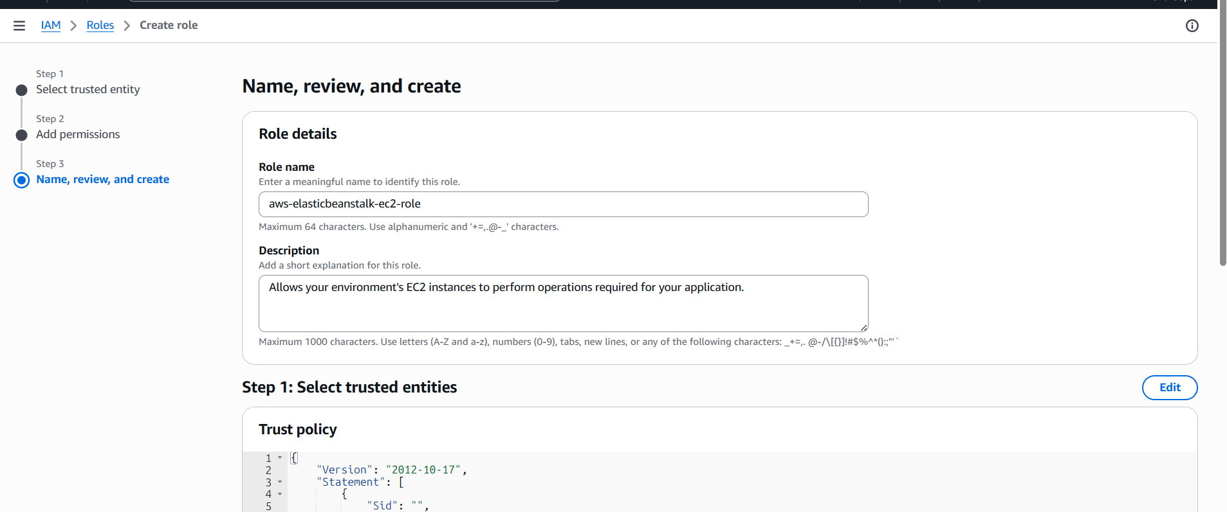
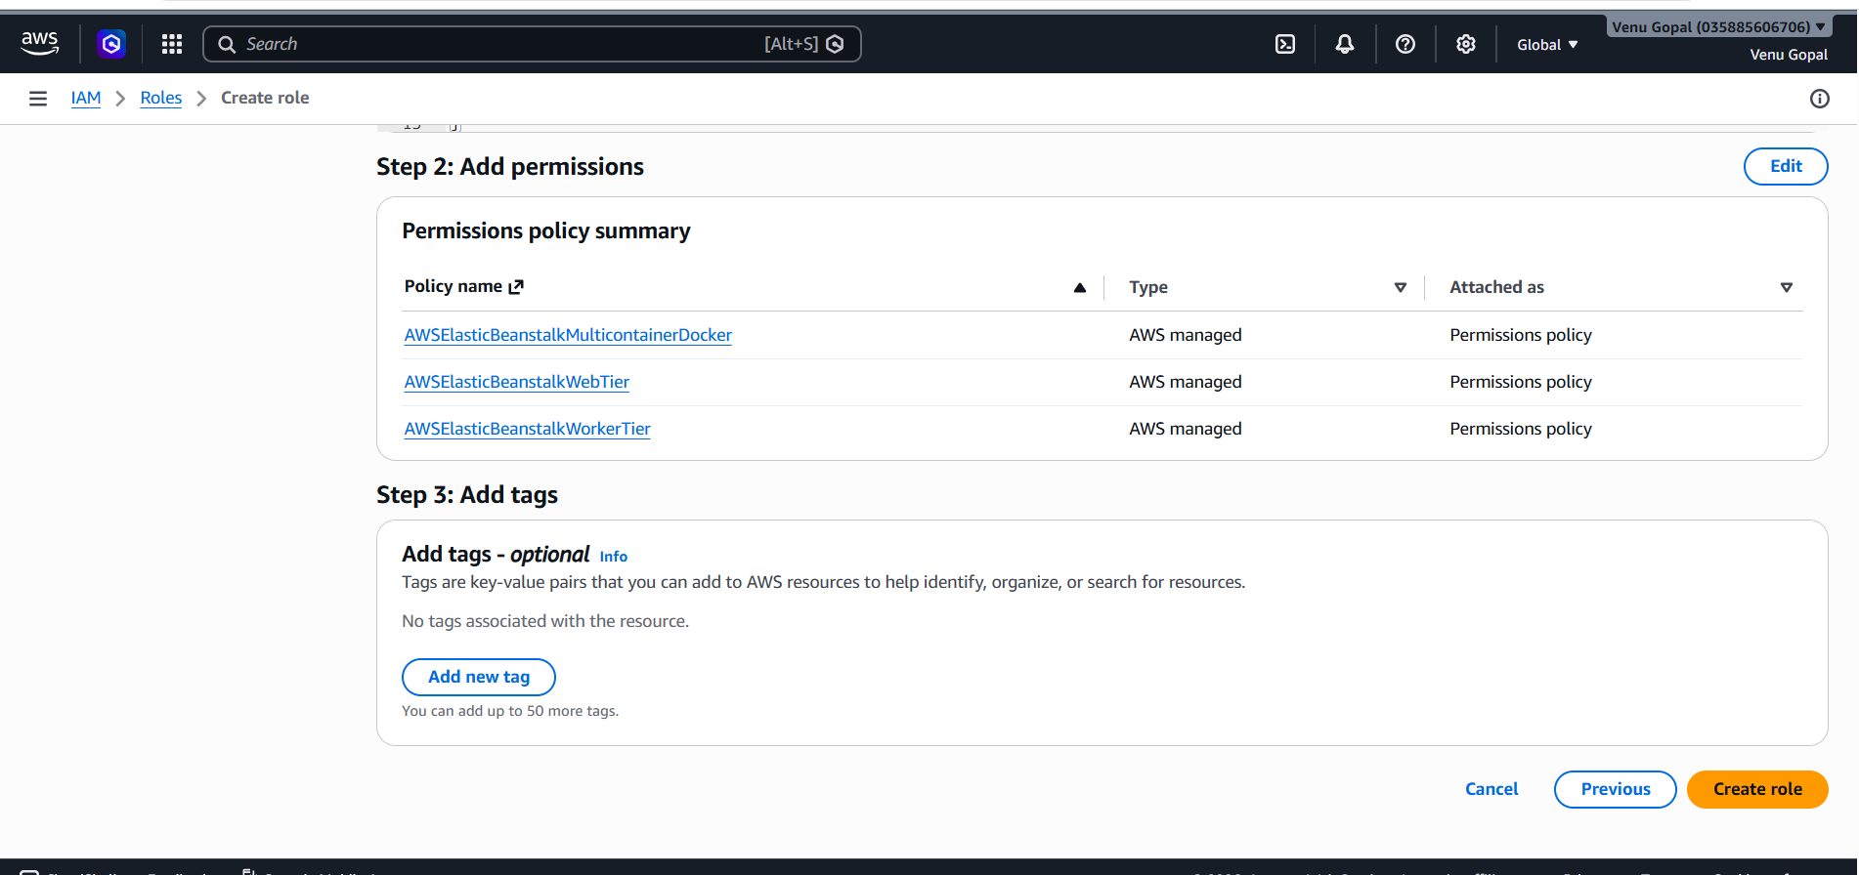
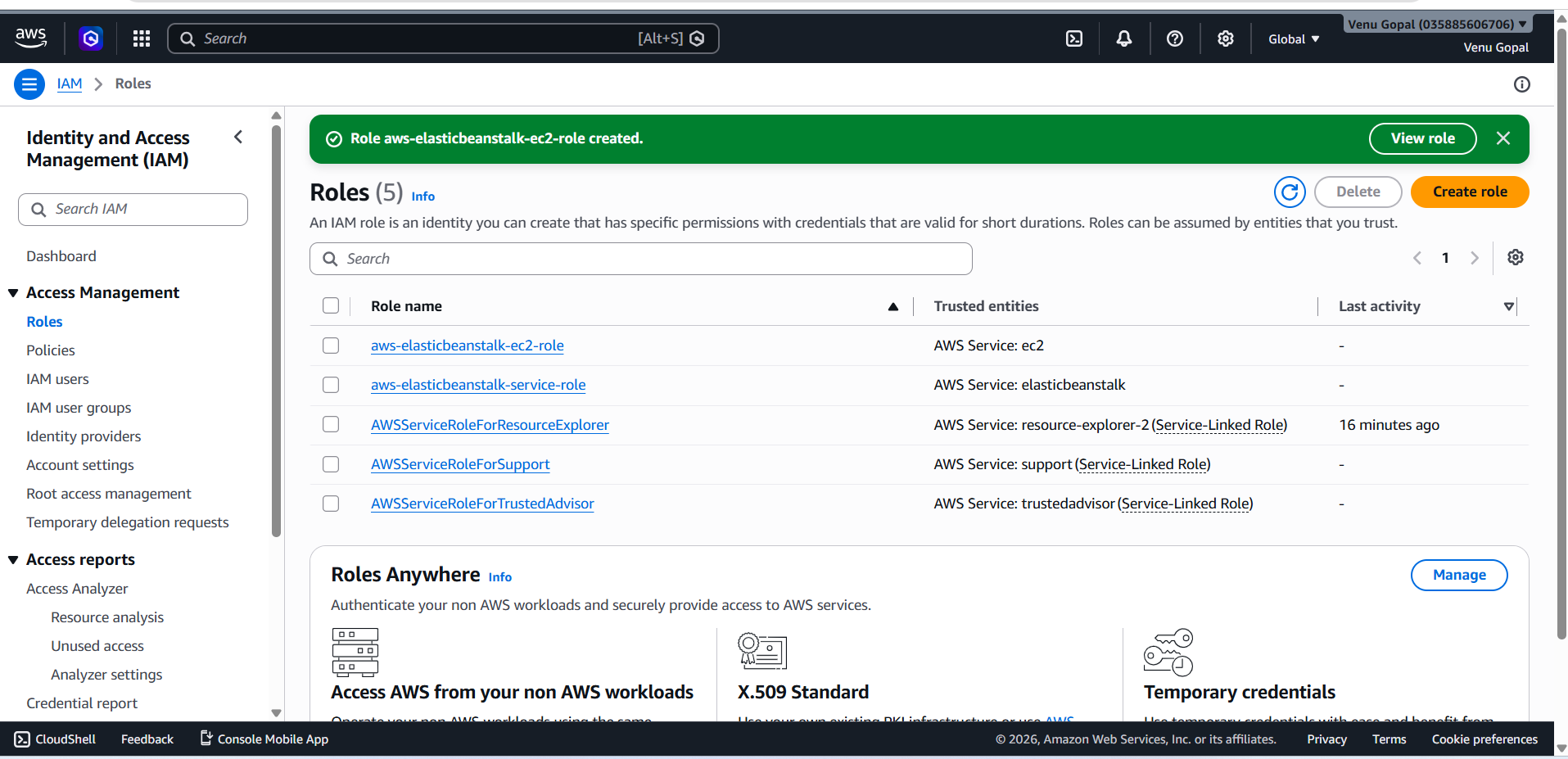

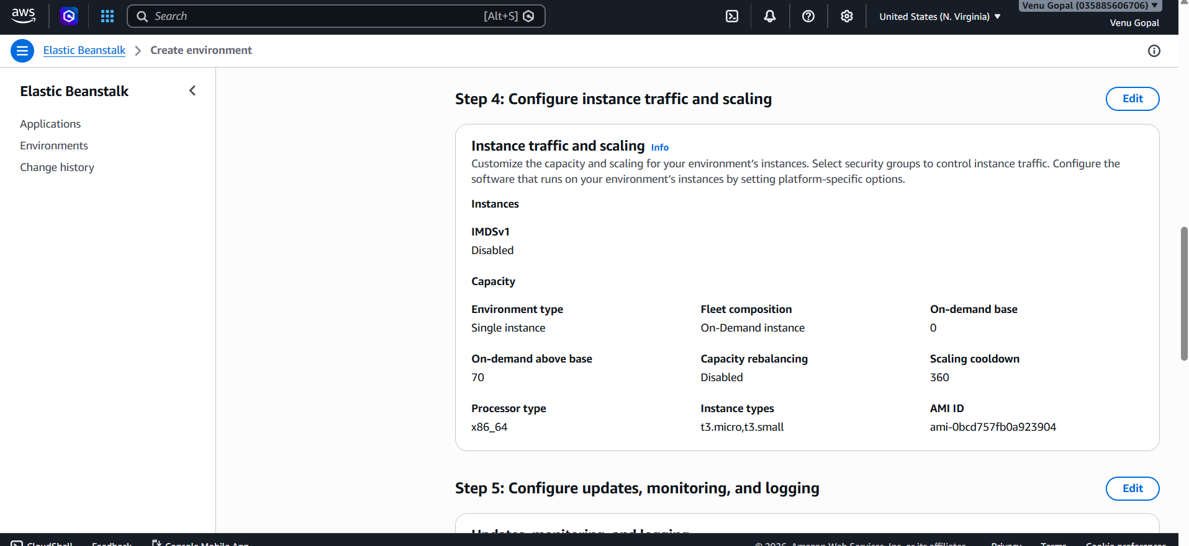

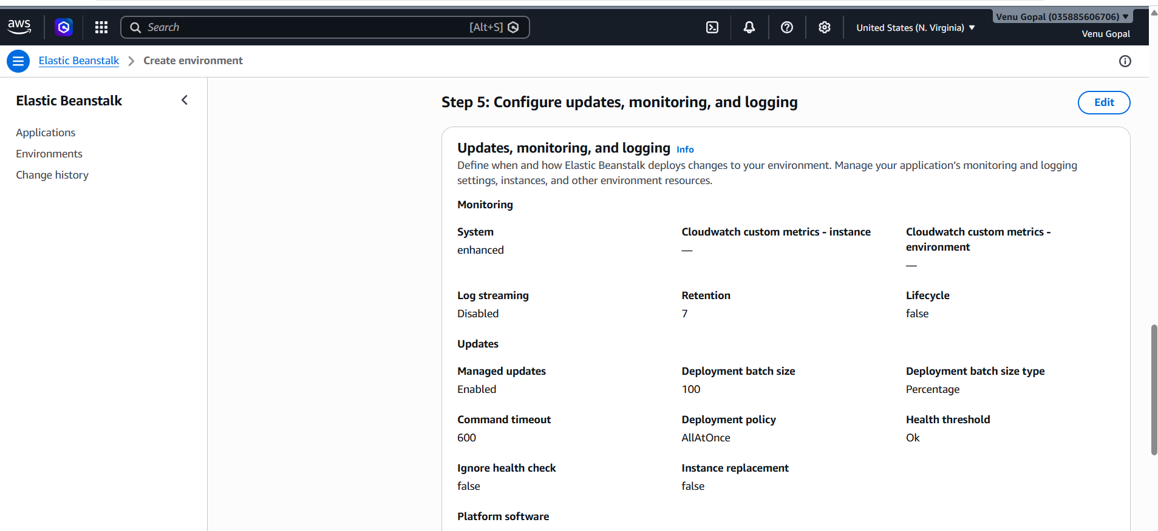
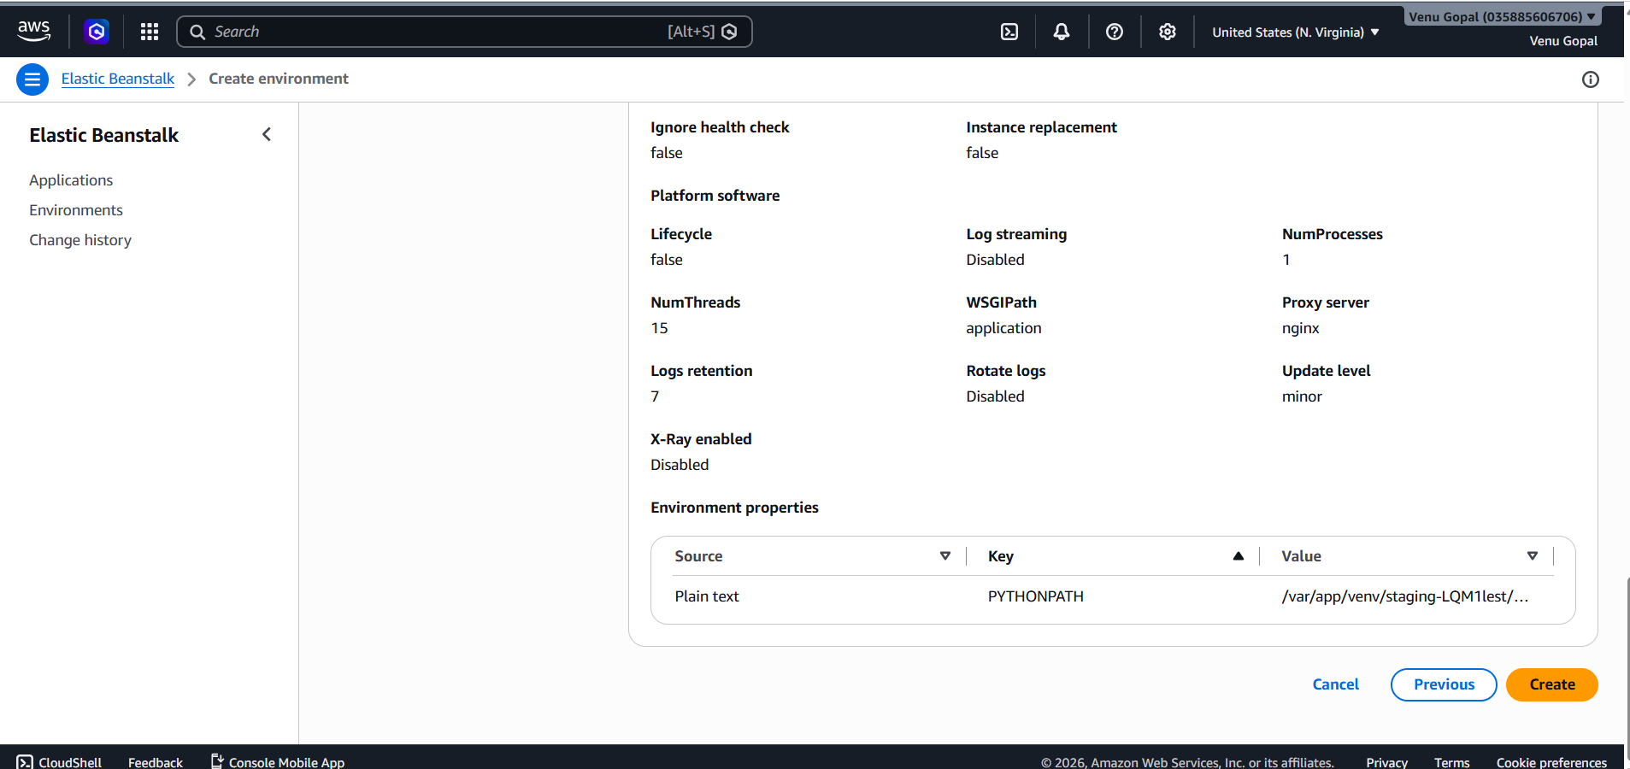

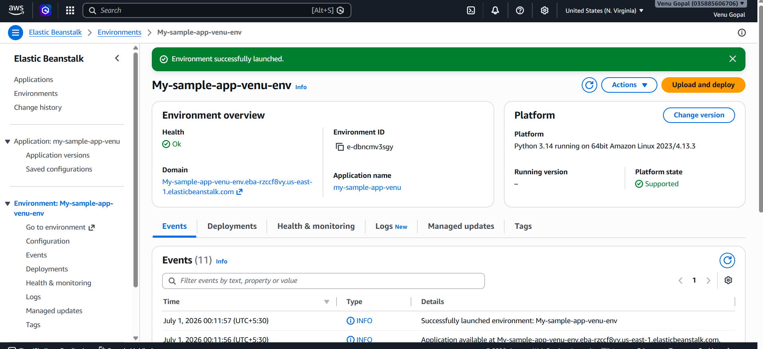
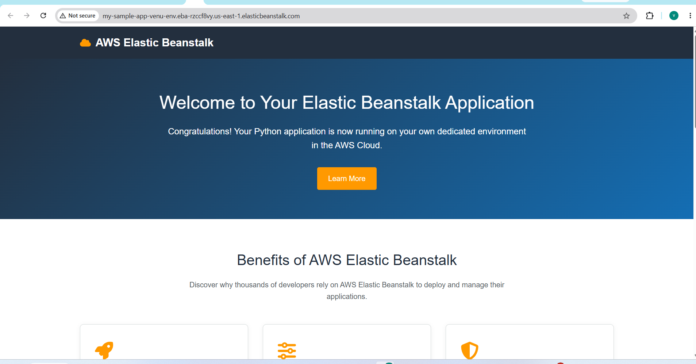
- Create a tomcat.service file for tomcat
To create a systemd service file for Apache Tomcat on Linux, create a new file named tomcat.service inside the /etc/systemd/system/ directory.
The tomcat.service File
Copy and paste the configuration below into your service file. Make sure to adjust the paths for JAVA_HOME, User, and Group to match your system configuration.
ini
[Unit]
Description=Apache Tomcat Web Application Container
After=network.target

[Service]
Type=forking

User=tomcat
Group=tomcat

Environment="JAVA_HOME=/usr/lib/jvm/java-17-openjdk-amd64"
Environment="CATALINA_PID=/opt/tomcat/temp/tomcat.pid"
Environment="CATALINA_HOME=/opt/tomcat"
Environment="CATALINA_BASE=/opt/tomcat"
Environment="CATALINA_OPTS=-Xms512M -Xmx1024M -server -XX:+UseG1GC"

ExecStart=/opt/tomcat/bin/startup.sh
ExecStop=/opt/tomcat/bin/shutdown.sh

Restart=always
RestartSec=10

[Install]
WantedBy=multi-user.target
Use code with caution.
Steps to Apply and Manage the Service
Follow these terminal commands sequentially to deploy and start your new Tomcat service:
- Create the file: Open a terminal editor to create the configuration file.
bash
sudo nano /etc/systemd/system/tomcat.service
Use code with caution.
- Reload systemd: Notify the system manager that a new service file has been added.
bash
sudo systemctl daemon-reload
Use code with caution.
- Start the service: Turn on Apache Tomcat immediately.
bash
sudo systemctl start tomcat
Use code with caution.
- Enable on boot: Ensure Tomcat starts automatically every time the server reboots.
bash
sudo systemctl enable tomcat
Use code with caution.
- Check status: Verify that the application container is running cleanly and without errors.
bash
sudo systemctl status tomcat
Use code with caution.

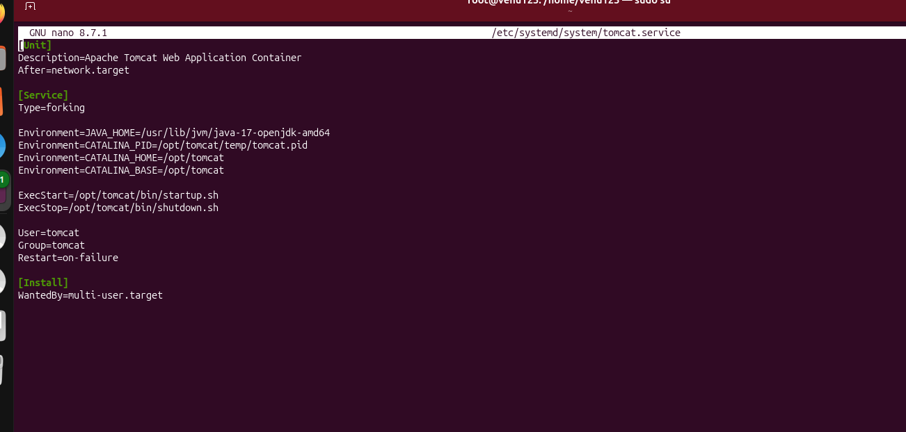
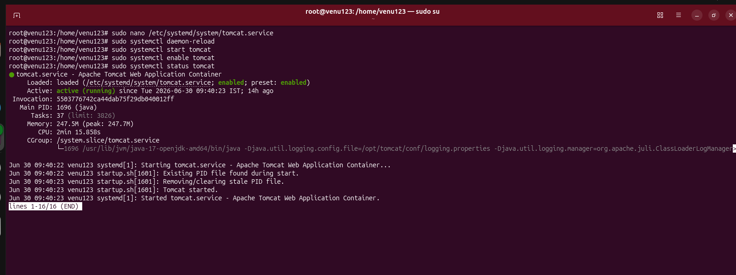

- Configure HA Proxy server:
To configure an HAProxy server using the AWS Console, you must launch an EC2 instance to host HAProxy, configure its security group permissions, and connect via EC2 Instance Connect to deploy the load-balancing configuration. AWS does not have a managed native "HAProxy service" UI, so the AWS Console is used to build the underlying infrastructure, while the actual HAProxy setup is completed inside the instance terminal.
Phase 1: Deploy Infrastructure in AWS Console
1. Configure the Security Group
Before launching the server, you need a firewall rule that allows web traffic to reach your load balancer.
- Open the Amazon EC2 Console.
- In the left navigation pane, choose Security Groups under Network & Security.
- Click Create security group.
- Add the following Inbound rules:
  - HTTP: Port 80 | Source: Anywhere-IPv4 (0.0.0.0/0) (or your specific network).
  - HTTPS: Port 443 | Source: Anywhere-IPv4 (0.0.0.0/0).
  - SSH: Port 22 | Source: My IP (to securely access your server terminal).
- Click Create security group.
2. Launch the EC2 Instance
- From the Amazon EC2 Console dashboard, click Launch instance.
- Name: Enter a name (e.g., HAProxy-Load-Balancer).
- Application and OS Images (AMI): Choose Ubuntu or Amazon Linux 2023.
- Instance Type: Select t3.micro or t3.small (sufficient for testing and moderate traffic).
- Key pair: Select an existing key pair or create a new one to enable safe terminal access.
- Network settings:
  - Click Edit.
  - Choose your target VPC and a Public Subnet.
  - Enable Auto-assign public IP.
  - Under Firewall, select Select existing security group and choose the security group created in step 1.
- Click Launch instance.
3. Allocate an Elastic IP (Highly Recommended)
An Elastic IP prevents your public IP address from changing whenever the HAProxy instance is stopped or restarted.
- In the left pane of the EC2 console, select Elastic IPs under Network & Security.
- Click Allocate Elastic IP address, then click Allocate.
- Select the newly created Elastic IP, click Actions, and choose Associate Elastic IP address.
- Select your HAProxy instance and click Associate.

Phase 2: Connect and Install HAProxy
- Go back to the Instances view in the Amazon EC2 Console.
- Select your HAProxy instance and click Connect at the top.
- Select the EC2 Instance Connect tab and click Connect to launch an in-browser terminal.
- Run the following commands to install HAProxy:
bash
# Update system packages
sudo apt update && sudo apt upgrade -y

# Install HAProxy
sudo apt install haproxy -y

# Verify installation
haproxy -v
Use code with caution.

Phase 3: Configure the Load Balancer
HAProxy behavior is defined within its central configuration file located at /etc/haproxy/haproxy.cfg.
- Open the configuration file using a terminal text editor:
bash
sudo nano /etc/haproxy/haproxy.cfg
Use code with caution.
- Append your routing rules to the bottom of the file. A basic layer 7 reverse-proxy template distributing traffic to two private backend web application servers looks like this:
haproxy
frontend http_in
bind *:80
mode http
default_backend web_servers

backend web_servers
mode http
balance roundrobin
option httpchk GET /health
# Replace with the private IP addresses of your actual target EC2 servers
server web-app-01 10.0.1.15:80 check
server web-app-02 10.0.1.26:80 check
Use code with caution.
- Save and exit the file (Press Ctrl+O, Enter, then Ctrl+X if using Nano).
- Test the configuration file structure for syntax errors before applying changes:
bash
sudo haproxy -c -f /etc/haproxy/haproxy.cfg
Use code with caution.
- If the validation passes, restart the HAProxy daemon to route live traffic:
bash
sudo systemctl restart haproxy
sudo systemctl enable haproxy
Use code with caution.

You can now copy your **Elastic IP address** from the AWS Console and paste it into a web browser to verify that traffic routes successfully to your backend servers.

If you would like, please share:
* The **operating system** you deployed on your EC2 instance (Ubuntu, Amazon Linux, RHEL, etc.)?
* Do your backend applications require **HTTP (Layer 7)** routing or raw **TCP (Layer 4)** routing?
* Do you need to set up **SSL/TLS termination** (HTTPS) directly on HAProxy?

With these details, I can provide the exact terminal commands and configuration updates for your production profile.

